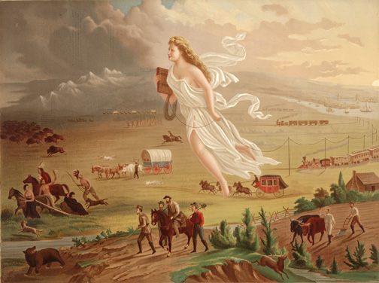
AMERICAN PROGRESS by John Gast

I have marked the text for the description that accompanied this painting. Prints of “American Progress” were seen all over the country.
Why would the government want to “advertise” moving West?

What are the “lurking, savage and wild beasts of prey?” Why are they “savage and wild?”

What makes the West the “treasure chamber of our country?”

What is the “Star of Empire?” What does it symbolize?

What is life like beyond the rays of light of the “Star?”

How does the author describe life the further West you get?

What are the Native American’s fleeing from?

Why does he describe Native Americans as the “noble red man?”

Why is this the “Great National Picture?”

What is the duty and DESTINY of Americans?

Using vocabulary words, how does this painting tell us about this period of time? Write a paragraph on the back of this sheet.
Words: Exploitation Annexation Nationalism
Superiority Inevitable Divine Right
Western Expansion Indian Removal Act Homestead Act
Gold Rush Transcontinental RR

