What is Sharecropping: 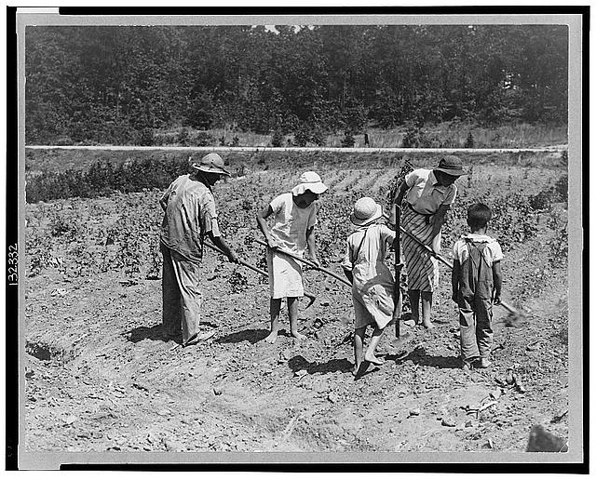

YOUR LIFE AS A SHARECROPPER
Directions: Today you have the opportunity of working as a sharecropper. What that means is that you get to work a piece of land from Mrs. Ennis in return for a small share of your crops. First: you need to sign your contract (below) then begin farming.
LAND USE CONTRACT:
To everyone applying to rent land you must read and follow these conditions.
- For every 30 acres of land we will give you a house, oxen, a plow, seeds and farming tools.

- You will receive ½ of the cotton, corn, wheat or other crops if you follow these conditions. If you do not, you will only receive 2/5ths.

- All work must be done by the sharecropper (YOU).

- When you have finished farming, you must bring our part to us.

- You are responsible for repairing the fences on the land.

- You may not work on any other plantation.

- You must pay all of your rent at harvest time.

- We will prepare cotton for you at a charge. You must give us your bags and ties.

- You may never take wood from the plantation without asking for permission.

I, THE UNDERSIGNED, AGREE TO THESE CONDITIONS.

X_________________________________________________DATE___________________

Now that you have your piece of land rented you need to start farming.
- You most likely have a family. List the members of your family here.

- Name of crop __________________ that you will be harvesting
(roll dice to decide: 1 or 3 = corn; 2 or 4 = wheat; 5 or 6 = cotton)

- The Plantation owners will supply you with housing, oxen, a plow, seeds and other tools. Take a look at your new home. Describe what you see. What type of a life would a person have it they lived in a home like this? Why?
__________________________________________________________________________________________
__________________________________________________________________________________________
__________________________________________________________________________________________
__________________________________________________________________________________________
__________________________________________________________________________________________
__________________________________________________________________________________________
__________________________________________________________________________________________
__________________________________________________________________________________________
__________________________________________________________________________________________
__________________________________________________________________________________________
__________________________________________________________________________________________
__________________________________________________________________________________________
__________________________________________________________________________________________

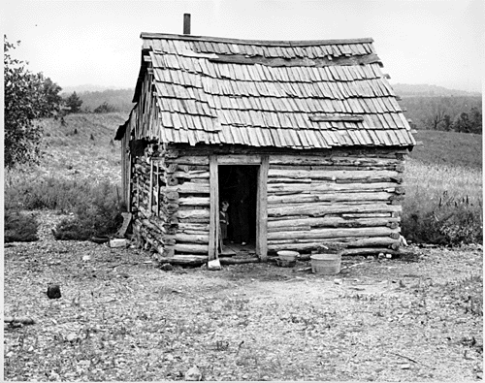

SHARECROPPER HOME: RUSTIC FIXER-UPPER…

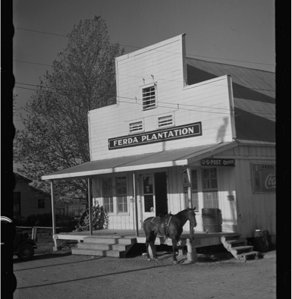
PLANTATION STORE
- What else do you need to work and live (remember what you got in #3)? Make a list of your basic necessities and find out how much they will cost from the plantation owners store.
GOODS | QUANTITY | X (TIMES) | PRICE | TOTAL
Food for 1 Person |  |  | $3
Clothing for 1 Person |  |  | $2
Shoes for 1 person |  |  | $1
Soap for 1 person |  |  | $1
Dishes for Family | (min of 1) |  | $5
Bed |  |  | $5
Furniture for Family | 1 |  | $5

GRAND TOTAL for SUPPLIES:_________________ ($6 min)

- Since you have NO money to buy supplies you need to take out a credit from the plantation owners. We charge 10% interest.
  - How much do you need to borrow (Grand Total from above)? __________________

  - How much must you pay back? (“a”X 1.1) ___________________

- You’re working hard on your land, but crops require a lot of LUCK to grow well. Roll dice to see how your crops are doing. (1 or 2 is draught = -15 acres; 3 or 4 is flood = -7.5 acres; 5 or 6 is nothing)

  - How many acres did you lose? ___________________________

- It’s harvest time! Find out how much your crop is selling for on the grain market and calculate how much money your crop will bring in, then go through the following deductions:

  - Market price per acre of crop: ________________________________
(wheat = $1/ac; corn = $1/ac; cotton = $2/ac)

  - Total number of acres you have: ________________________________
(30 – anything you lost in #6)

  - Initial total after sale (7a x 7b): ________________________________

- Deductions:
  - If you grew cotton deduct $20 for the cotton preparation: _______________

  - How much do you owe the Plantation owners for supplies? _______________
Total Deductions (a + b) _______________

- So, what have you gained from your year of sharecropping? Subtract your total deductions from your initial crop sale to see what you have left.
  - Initial crop sale (Your Answer for 7c): ______________________
Minus --
  - Total deductions (Your Answer for 8b): ______________________
=
  - Net EARNINGS for the year: ______________________
(How much money you made)

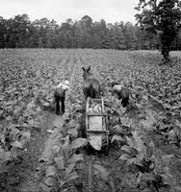
ANSWER THESE QUESTIONS AFTER YOU HAVE FINISHED THE ACTIVITY:

- Now that you’ve been through it, HOW do you feel about sharecropping? WHY?
_________________________________________________________________________________
_________________________________________________________________________________
_________________________________________________________________________________
_________________________________________________________________________________
_________________________________________________________________________________
_________________________________________________________________________________

- What parts of this activity seemed unfair and would make it hard for you to get ahead (make a lot of money?
_________________________________________________________________________________

_________________________________________________________________________________
_________________________________________________________________________________
_________________________________________________________________________________
_________________________________________________________________________________
_________________________________________________________________________________

- How would sharecropping hurt African Americans and keep them from gaining more power during Reconstruction?
_________________________________________________________________________________
_________________________________________________________________________________
_________________________________________________________________________________
_________________________________________________________________________________
_________________________________________________________________________________
_________________________________________________________________________________
_________________________________________________________________________________
_________________________________________________________________________________
_________________________________________________________________________________

