Menu |  | - June 28, 1914  - The Great War: World War I
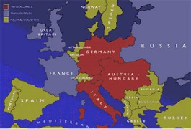  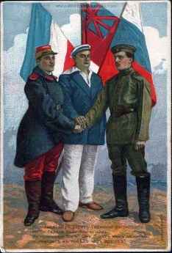  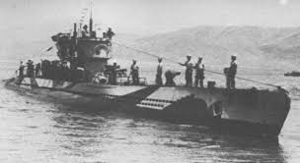 |  | Antipasto  What were the conditions in Europe leading up to the war?  Appetizer  What started the war?  Soup  Allies:  Central Powers:  Main course  What made this war different than previous ones? (how was it fought – style, weapons)  Why did the U.S. get involved?

Side dishes
What was going on at home with:
Women?

African Americans?

“Spies”?

Propaganda?

Dessert
How did the war end?

What was “Peace Without Victory?”

Describe Wilson’s 14 Points and the Versailles Treaty. (what did they cover, how did the American public feel about them)

  - Aperitif
Describe post-war life in the US. (changes in labor force, economuy)

Choose ONE of the following questions to answer in a 2 paragraph short essay.

1. Briefly describe how Nationalism changed over the course of time leading up to WWI?

2. What role did alliances play throughout WWI: prior to, the beginning, throughout and the end?

3. Why was the war a stalemate? What is a stalemate and what caused it in WWI?

4. What role did propaganda play at home in regards to the war? (Red Scare, public support, conserving goods)

Invitation to Attend

PRESIDENT WILSON AND THE UNITED STATES OF AMERICA ARE CORDIALLY INVITED TO JOIN THE ALLIED POWERS IN THE FIGHT AGAINST TYRANNY!

WHEN: 6 APRIL 1917

WHERE: FRANCE

PLEASE RSVP TO GEORGES CLEMENCEAU OF FRANCE, KING GEORGE V OF GREAT BRITIAN OR CZAR NICHOLAS II OF RUSSIA

WE HOPE YOU CAN JOIN US IN OUR QUEST TO STOP KAISER WILHELM OF GERMANY AND THE CENTRAL POWERS FROM TAKING OVER EUROPE.

Please bring your own troops, weaponry and ammunition.

